# CHAPTER FOUR

# RESULT AND DISCUSSION

## 4.1 Introduction

This chapter will present the result of the designed system. It will be discussed under the following subheadings:

1. Results
2. Discussion
3. User Manual

## 4.2 Result

The result of this system has given the expected result and therefore it is presented below using figures

**4.2.1 Home page**

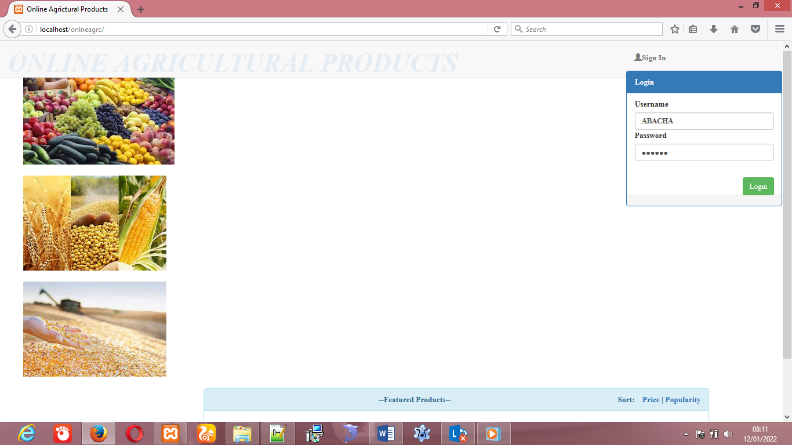

Figure 4.1: Home page

The figure above shows the home page of the online Agricultural products, it is the index page of the portal

## 4.2.2 Login form

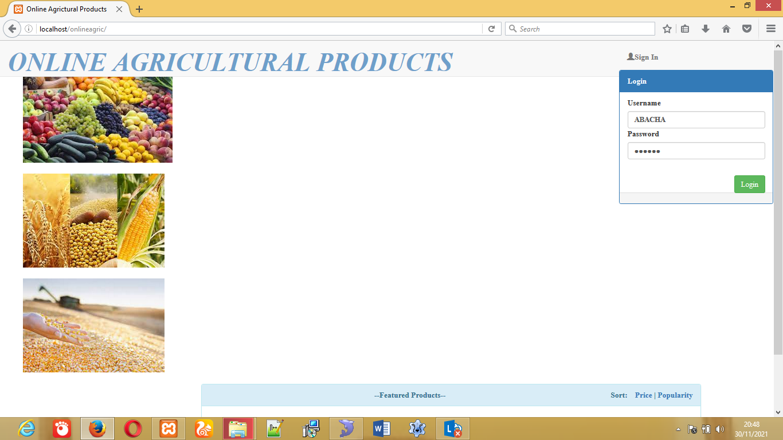Figure 4.2: Login form

The above figures shows the login form into the system, admin can login uses his password and user can login uses the password that was created for him.

## 4.2.3 Register item

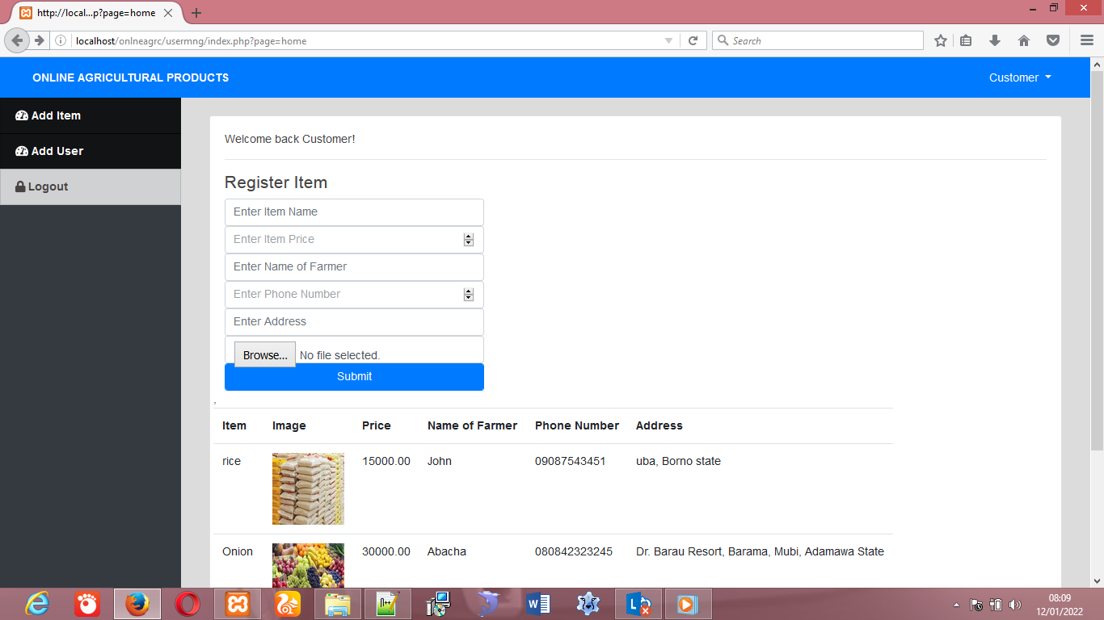

Figure 4.3: Register item.

The above figure shows the Register item form. Admin can add item of different farmer to the website.

## 4.2.4 Product Table

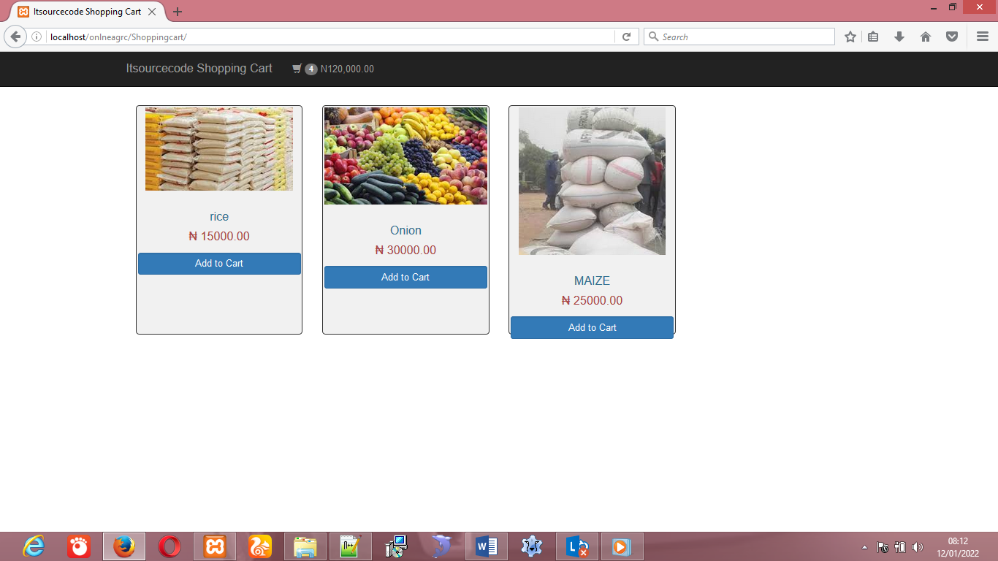

Figure 4.4 Products form

The above figure shows the different products that customer may need online.

## 4.2.5 The shopping card

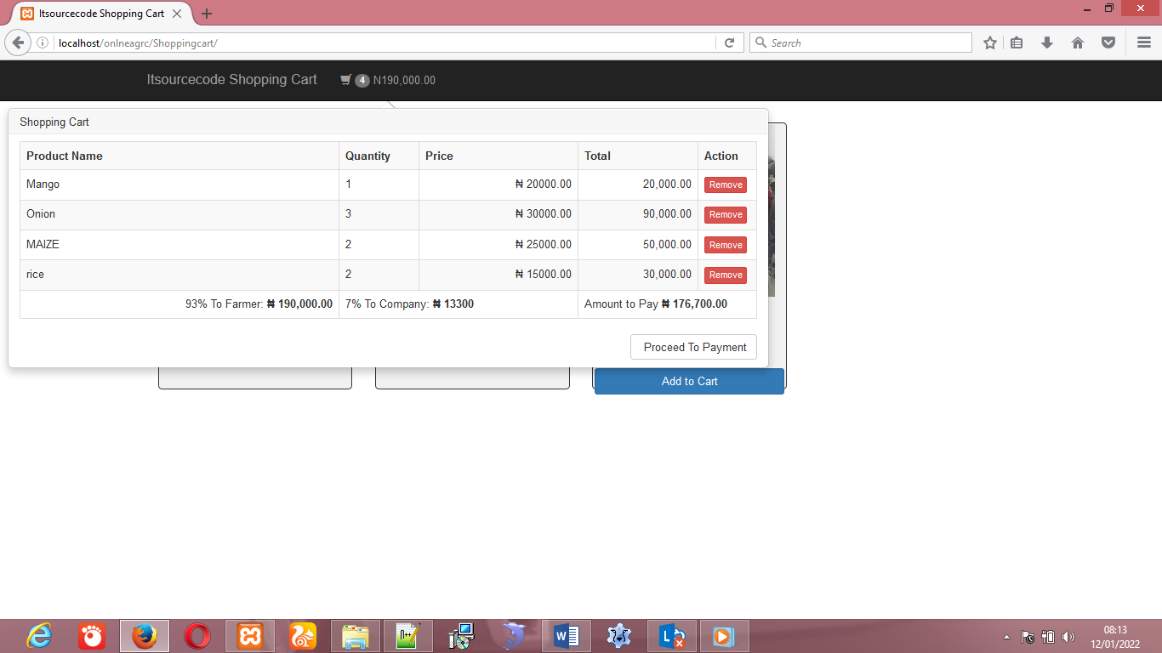

Figure 4.5 The shopping Card

The above is card that aloud customer to buy products online, make the Payment. And it also calculate the percentage to owner of the company

**4.2.6 Payment form**

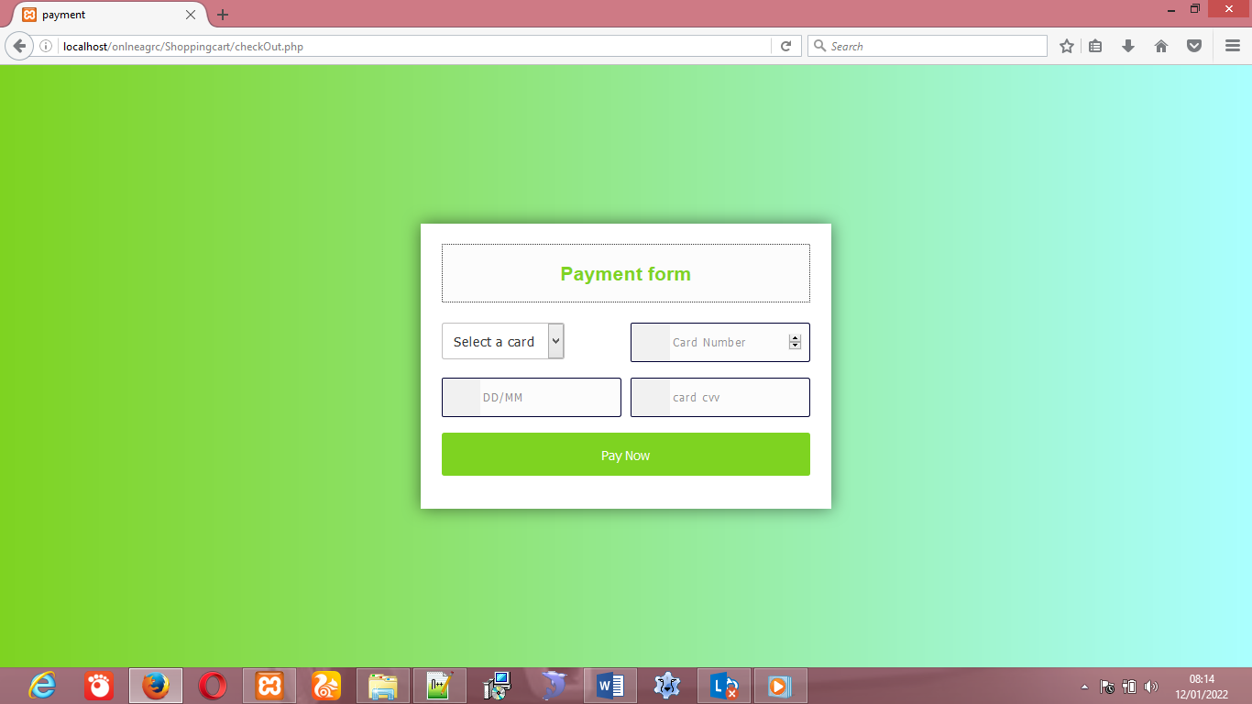

Figure 4.6 Payment form

The above is card showing the payment of the products online.

## 4.3 Discussion

The research work, titled Design and implementation of a web-based system that will link farmer to buyers , it is found to have been achieved its purpose of which the system has been design. All system functionality has been tested and the tested data has been screenshot and presented with labels as seen from figure 4.2.1 to figure 4.2.5 above. The goal of designing the system has meet the requirement of the problem addressed.

## 4.4 User Manual

For any new system designed, it is expected to accompany with its user manual. User manual helps the user to know how to work with system. Therefore, below are the steps to be followed in trying to use the system.

**Requirements**

1. First, functional computer system
2. Web browser of any type and version (eg. Chrome, Firefox, Internet explorer etc)
3. Server (e.g Xammpp, Wamp, Unix server if run offline) or
4. Internet connection if hosted

**Steps**

1. Launch a browser and go to Address bar
2. Type in the URL of the system if hosted or
3. Start the server if offline, and in the address bar,
4. Type in “localhost/agric/”
5. Now you are ready to use the system
6. Done!!!!

# CHAPTER FIVE

# SUMMARY, CONCLUSION AND RECOMMENDATIONS

## 5.1 Summary

The project is aimed at designing online website that will link farmer to customers. Some literatures were reviewed, and methodology for project was survey method were the research did thorough investigation and observation. The modality adopted for the system was agile method and generic algorithm was used to solve the problem. The system is designed using MySQL and php scripting language. The purpose which the system is designed has been achieved. Data were tested and the system functions as expected. Report were done using screenshot of the tested data and presented with label using figures as shown in the figures above. The result was presented and discussion was done in chapter four. The researcher provides user manual for user operation.

## 5.2 Conclusion

This research work focuses on the use of computer system with reference to desiging a online website that will link the farmer to customer. The work covers the manual system of opertions as regards the problems identified, stating the aims of the new system, stating the various specifications and then implementing the programs. The work was successufully developed using php, javascript scripting languages in an HTML environment, a user- friendly programming language, and the package was tested and improved upon which yields interactive website for saling farm product.

The project work cannot be said to be perfect, but however, its benefits cannot be overemphasized. It has led to the improvement in the speed of processing operation, efficiency, accuracy and improved storage of data.

Realizing a project of this nature is very exciting. However, the farmer encounter a lot a problem which I believe if looked into, will go a long way toward reducing the tension associated with the design implementation and construction of the project. In spite of the constraints encountered during the implementation of this project, the aim of my project is well accomplished.

## 5.3 Recommendations

Based on the achieved objective of this project and the experiences gained during its designed and implementation, I wish to make the following recommendations for future improvement.

1. Students should be exposed to serious practical exercise during the course of their studies. In this regard, the students of Computer Science & Information Technology should be made to write at least a working program with veritable results before graduating. This could be accomplished by providing more computers qualified lecturers in the department.
2. Farmer should adopt and expand the project for efficient operation and advertisement of their farm product activities.
3. Research done by student should be published with the help of supervisor for institution reputation.

## 5.4 Contribution to Knowledge

The outcome of this research will greatly contribute to the minimizing of the space and time saving when customers retrieving the farm product manual from farmer. And the new program promote the manual method, to online method.

## 5.5 Area for further work

Further research can be done on design a website that will link farmer to buyer, in advance way because of the rapid changes of the methodology. Design website that will link farmer two buyer online, by uses different programing languages.